**REPORT**

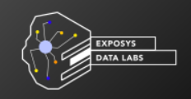

**EXPOSYS DATA LABS**

**SOFTWARE DEVELOPMENT INTERNSHIP**

**Name** : Akash Ramanand Rajak

**E mail** : aakashrajak02@gmail.com

**College** : Indian Institute of Information Technology, Kalyani

**Department** : B Tech / CSE

**TASK**

1.) Try to build or change an existing algorithm to secure message send by the user based on efficiency.

2.) Confirm the identity of the user by entity authentication using verification and validation.

**TASK TIME:** 29th Jul to 1st Sep

**OVERVIEW**

In this task, created a text message securing algorithm by changing something in the existing algorithm i.e. RSA algorithm(which is considered to be the most secure algorithm in the field of cryptography).

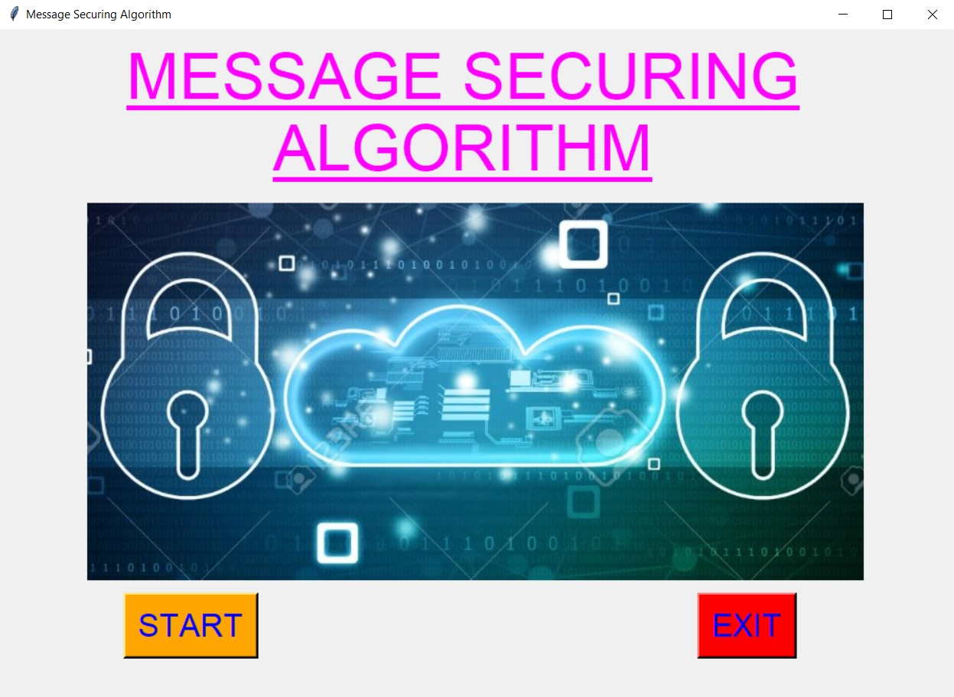

Used Python Language to implement this algorithm. Here code allows user to enter any text message in the text area provided and with the help of given buttons, will be able to encrypt, decrypt and authenticate the user entity.